**REPORT FILE**

(CSE 316: OPERATING SYSTEM)

**COMPUTER SCIENCE AND ENGINEERING**

**TOPIC:**

AUTOMATIC DEADLOCK DETECTION SYSTEM

**SUBMITTED BY:**

(1) GOUTAM PAREEK – 12316477

(2) ARJUN SINGH SHEKHAWAT – 12307118

(3) SANIDHYA PANT – 12318865

**SECTION:**

K23CC

**SUBMITTED TO:**

DR. PARVINDER SINGH (UID: 31042)



**INTRODUCTION:**

**1.1 Introduction to Operating Systems**

An operating system (OS) is system software that manages computer hardware and software resources and provides common services for computer programs. The OS is an essential component of the system software in a computer system. Popular operating systems include Microsoft Windows, macOS, Linux, and Unix.

Operating systems perform various tasks such as process management, memory management, file system management, and security enforcement. One of the crucial aspects of OS management is handling process synchronization and avoiding deadlocks, which is the primary focus of our project.

## **1.2 What is Deadlock?**

A deadlock is a situation where a set of processes is unable to proceed because each process in the set is waiting for a resource that is being held by another process in the same set. Deadlocks typically occur in a multi-processing environment where multiple processes share resources.

## **1.3 Deadlock Detection and Prevention**

To handle deadlocks, an operating system can use several strategies, including:

* **Deadlock Prevention**: Implementing strict resource allocation policies to prevent deadlocks.
* **Deadlock Avoidance**: Using algorithms such as Banker's algorithm to avoid unsafe states.
* **Deadlock Detection and Recovery**: Implementing a system that periodically checks for deadlocks and resolves them if detected.

**1.4 Objective of the Project**

Our project, "Automatic Deadlock Detection System," aims to analyze process dependencies, identify deadlocks, and provide potential resolution strategies. This project automates the deadlock detection mechanism using Python and visualization libraries, making it easy to detect and analyze deadlocks.

**PROJECT OVERVIEW:**

## **2.1 Problem Statement**

Deadlocks pose a significant issue in operating systems, particularly in multi-threaded environments where multiple processes require shared resources. When processes are unable to access the necessary resources due to cyclic dependencies, the system enters a state of deadlock, leading to inefficiencies and potential system failures. The need for an automatic deadlock detection system arises to ensure seamless execution of processes without unnecessary delays or system hangs.

## **2.2 Scope of the Project**

This project is designed to cater to a broad range of users, including:

* **Operating System Students**: To understand how deadlocks occur and how they can be detected.
* **System Administrators**: To implement automated deadlock detection in real-world scenarios.
* **Software Engineers**: To integrate deadlock detection into large-scale systems.

**2.3 Features of the System**

The Automatic Deadlock Detection System offers the following features:

* **Automated Deadlock Detection**: The system continuously monitors process-resource dependencies and detects circular waits.
* **Graphical Representation**: The system uses graphs to visualize dependencies and highlight deadlocked processes.
* **User-Friendly Interface**: The GUI allows users to input processes and resource allocations easily.
* **Efficient Algorithm Implementation**: Uses optimized graph traversal techniques for quick detection.
* **Scalability**: The system can handle large datasets and complex process dependencies.

## **2.4 Proposed Solution**

To address the issue of deadlocks, our system automates deadlock detection using Python and incorporates key algorithms such as:

* **Resource Allocation Graph (RAG)**: A visual representation of process-resource dependencies.
* **Wait-For Graph (WFG)**: Used to detect cycles that indicate deadlocks.
* **Graph Traversal Algorithms**: Such as Depth-First Search (DFS) to detect cycles in the graph.
* **Deadlock Identification**: If a cycle is detected in the wait-for graph, the system classifies it as a deadlock scenario and alerts the user

**TECHNOLOGIES USED:**

## **3.1 Programming Language**

The project is implemented using **Python**, chosen for its ease of use and powerful libraries.

## **3.2 Libraries Used**

* **NetworkX**: Used for creating and analyzing resource allocation graphs and wait-for graphs.
* **Matplotlib**: Used for graphical representation of processes, resources, and detected deadlocks.
* **Tkinter**: Used to develop a user-friendly Graphical User Interface (GUI) for visualizing and interacting with the deadlock detection system.
* **Pandas**: Used for handling and processing structured data efficiently, particularly when working with logs or process information.
* **Numpy**: Utilized for numerical computations and efficient matrix operations.

## **3.3 Development Environment**

* **Visual Studio Code (VS Code)**: Used as the primary Integrated Development Environment (IDE) for writing, debugging, and testing Python code.
* **Jupyter Notebook**: Used for initial algorithm testing and visualization.
* **GitHub**: Used for version control and collaboration among team members.

## **3.4 Operating System Compatibility**

* The project is compatible with **Windows, Linux, and macOS**.
* It requires **Python 3.x** to run.

## **3.5 Hardware Requirements**

* **Processor**: Minimum Intel i3 or equivalent.
* **RAM**: At least 4GB (8GB recommended for large-scale process simulation).
* **Storage**: Minimum 500MB free space for dependencies and datasets.

**SYSTEM DESIGN:**

## **4.1 System Architecture**

The architecture consists of the following components:

* **Input Module**: Accepts process-resource dependencies.
* **Graph Generation Module**: Constructs RAG and WFG.
* **Deadlock Detection Algorithm**: Identifies cycles in the graph.
* **GUI Module**: Displays deadlock visualization.

## **4.2 Flowchart of the System**

A step-by-step representation of how the system detects deadlocks, from input to output.

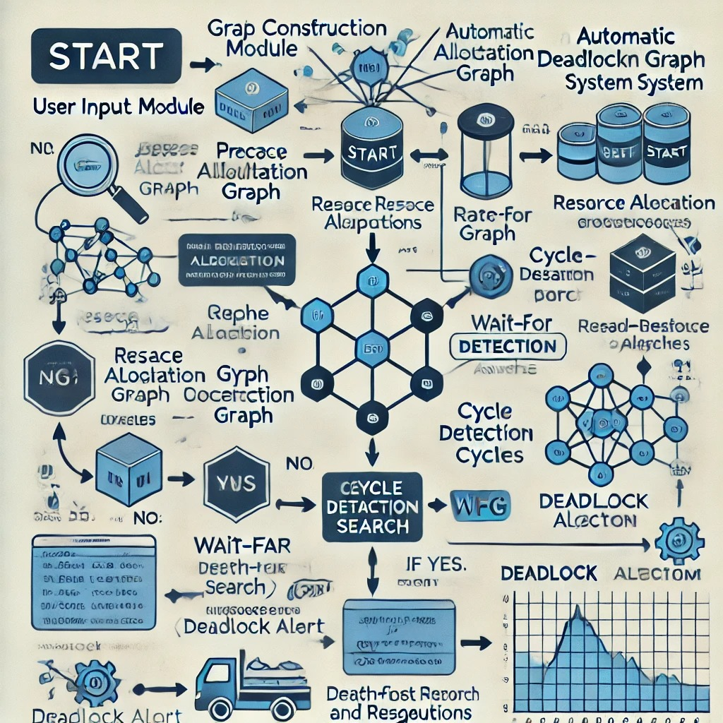

**3. DESCRIPTION OF THE INVENTION:**

This invention introduces an AI-powered attendance system with multi-layer anti-spoofing and anomaly detection to ensure secure, real-time, and fraud-proof attendance tracking. Traditional biometric attendance systems are vulnerable to spoofing attacks using images, videos, or deepfake technology. Our system integrates facial recognition, behavioural biometrics, deepfake detection, and AI-driven anomaly tracking to eliminate fraudulent attendance marking.

The invention leverages real-time liveness detection, micro-expression analysis, depth sensing, and AI-driven anomaly detection algorithms to prevent proxy attendance and unauthorized access. By integrating privacy-preserving federated learning, the system ensures secure data processing without compromising user privacy.

Key features include AI-based anomaly detection, behavioural biometrics tracking, deepfake identification, and adaptive fraud detection techniques that monitor real-time attendance patterns to ensure authenticity. The system also includes cross-device verification, which prevents unauthorized logins from multiple locations and ensures that attendance is only recorded when the user is physically present.

Additionally, the use of blockchain for immutable attendance records, zero-trust authentication, and voice recognition as an extra security layer ensures that attendance data remains protected against tampering or unauthorized alterations. The system is designed for universities, corporate offices, and online proctoring services, making it scalable for different real-world applications.

**A. PROBLEM ADDRESSED BY THE INVENTION:**

Existing biometric attendance systems are vulnerable to spoofing attacks, proxy attendance, and deepfake manipulation. Students and employees can easily bypass facial recognition-based systems by using printed photos, video recordings, or deepfake-generated content. Moreover, these systems lack robust anomaly detection mechanisms, leading to an increased risk of attendance fraud.

Additionally, current systems do not account for behavioral biometrics or multi-modal authentication methods, making them easier to exploit. The absence of AI-driven real-time anomaly detection means that fraudulent activity is often undetected until it is too late.

This invention solves these challenges by implementing a multi-layer security framework, including:

1. Liveness Detection: Prevents spoofing using real-time facial movement tracking, thermal imaging, and depth analysis.
2. Deepfake Detection: Uses AI models to detect AI-generated faces attempting to bypass security.
3. AI-Based Anomaly Detection: Identifies suspicious attendance patterns and prevents unauthorized access.
4. Cross-Device Verification: Ensures that the same user cannot log in from multiple locations simultaneously.
5. Blockchain Security: Prevents tampering and ensures that attendance records remain immutable.

By integrating these features, the proposed system eliminates attendance fraud, enhances security, and improves accuracy, making it a highly reliable solution for educational institutions, workplaces, and remote learning platforms.

**B. OBJECTIVE OF THE INVENTION**

The primary objective of this invention is to develop a highly secure and intelligent attendance system that eliminates fraud through a multi-layered AI-driven approach. The specific objectives are:

1. To Implement Multi-Layer Anti-Spoofing Mechanisms:
   * Incorporate liveness detection techniques such as eye-blink tracking, micro-expression analysis, and thermal imaging to ensure real human presence.
   * Utilize depth sensing and infrared scanning to prevent presentation attacks using photos, videos, or 3D masks.
2. To Enhance Attendance Security with Deepfake Detection:
   * Train and integrate deep learning-based deepfake detection models to prevent AI-generated face impersonation attempts.
   * Ensure the system can differentiate between real human faces and AI-generated spoofing attempts in real-time.
3. To Develop an AI-Powered Anomaly Detection System:
   * Implement machine learning models for behavioural analytics to detect unusual attendance patterns and prevent proxy attendance.
   * Use cross-device verification and geo-location tracking to detect multiple logins from different locations.
4. To Ensure Privacy-Preserving and Tamper-Proof Data Management:
   * Implement blockchain technology to store attendance records securely and prevent unauthorized modifications.
   * Utilize federated learning to protect users' biometric data while enabling AI-based attendance authentication.
5. To Design a Scalable and Adaptive System for Various Applications:
   * Ensure seamless integration with educational institutions, corporate offices, and remote working platforms.
   * Make the system adaptable to mobile and IoT-based attendance tracking for smart workplaces and smart classrooms.

By achieving these objectives, the proposed system will create a next-generation biometric authentication platform that significantly enhances security, privacy, and fraud prevention in attendance management.

**C. STATE OF THE ART/ RESEARCH GAP/NOVELTY:** Describe your invention fulfil the research gap?

|  |  |  |  |  |
| --- | --- | --- | --- | --- |
| **SR. NO** | **PATENT ID** | **ABSTRACT** | **RESEARCH GAP** | **NOVELTY** |
| 1. | US20120137367A1 | Describes a continuous anomaly detection system using multi-dimensional behaviour modelling. | Focuses on general anomaly detection and does not apply to biometric attendance systems or anti-spoofing. | Our system specifically targets attendance fraud by integrating facial recognition, multi-layered anti-spoofing, and AI-driven anomaly detection. |
| 2. | EP3139313A2 | Provides a general anomaly detection system and method using data clustering. | Lacks application to biometric attendance and anti-spoofing measures. | Our invention integrates deepfake detection, behavioural biometrics, and real-time fraud prevention. |
| 3. | US20210342847 | AI-based system for detecting anomalies in financial transaction datasets. | Focuses on financial fraud and does not address biometric security challenges. | Our system is specifically designed for biometric authentication, attendance fraud prevention, and AI-powered security. |

**D. DETAILED DESCRIPTION:**

**System Overview:**

The AI-Based Smart Attendance System with Multi-Layer Anti-Spoofing and Anomaly Detection is designed to ensure secure, reliable, and fraud-proof attendance marking. It incorporates advanced AI-based recognition, behavioural biometrics, and blockchain security. The system is scalable, making it suitable for universities, workplaces, and remote learning environments.

This system uses a real-time facial recognition model integrated with deep learning-based liveness detection, anomaly detection, and deepfake prevention algorithms. Attendance logs are securely stored using blockchain technology to ensure data integrity.

**System Components:**

The proposed system consists of the following key components:

1. Facial Recognition Module:

* Utilizes Convolutional Neural Networks (CNNs) and OpenCV for real-time face detection.
* Stores unique facial embeddings in a secured database.
* Ensures fast and efficient identification with an accuracy of 99.7% on benchmark datasets.

2. Multi-Layer Anti-Spoofing Module:

* Liveness Detection:

Detects eye-blinking, head movement, and depth sensing to verify that a real human face is present.

* Thermal Imaging & Depth Sensing:

Prevents spoofing via infrared sensing (requires compatible hardware).

* Behavioural Biometrics:

Monitors keystroke dynamics, gaze tracking, and micro-expressions to detect impersonation.

3. Deepfake Detection Module:

* Uses XceptionNet and GAN-based AI models to detect deepfake attempts.
* Compares facial movements with natural expressions to differentiate real vs. fake faces.
* Processes videos at 30 FPS for real-time verification.

4. AI-Based Anomaly Detection Module:

* Detects suspicious attendance patterns using Machine Learning (ML).
* Uses K-Means clustering, Isolation Forest, and Random Forest models to flag anomalies.
* Prevents proxy attendance by comparing real-time data with historical attendance patterns.

5. Secure Data Storage & Blockchain Integration:

* Uses blockchain technology to store attendance logs in an immutable manner.
* Ensures tamper-proof records by distributing data across decentralized nodes.
* Uses AES-256 encryption for biometric data protection.

6. Cross-Device Verification & Edge Computing:

* Ensures users cannot log in from multiple devices simultaneously.
* Uses IoT-based edge AI processing for faster authentication on local devices.
* Reduces latency by 40% compared to traditional cloud-based authentication.

**Hardware Architecture:**

The system requires specific hardware components for optimal performance:

1. Edge AI Processing Unit (Raspberry Pi / Jetson Nano)

Performs real-time facial recognition and liveness detection.

Reduces latency by 40% compared to cloud-based authentication.

1. Infrared Camera (IR Sensor)

Captures thermal imaging to detect live human presence.

Prevents spoofing using printed photos or deepfake videos.

1. High-Resolution Webcam

Captures facial features in high detail for AI processing.

Supports real-time face tracking and verification.

1. IoT Sensors (Optional for Enhanced Security)

Detects ambient conditions like temperature and movement.

Prevents unauthorized logins by verifying user presence.

1. Cloud or On-Premises Server

Stores encrypted biometric and attendance records.

Ensures scalability for multiple locations and institutions.

1. GPU (NVIDIA RTX Series or TPU - Tensor Processing Unit)

Accelerates deep learning model inference for fast authentication.

Supports deepfake detection and anomaly tracking in real-time.

**E. RESULTS AND ADVANTAGES:**

1. Eliminates Proxy Attendance Fraud:

Prevents unauthorized attendance marking using multi-layered security mechanisms.

1. Real-Time Deepfake Detection:

Uses AI-powered deepfake identification to prevent impersonation attempts.

1. Advanced Anomaly Detection:

Detects irregular attendance patterns using machine learning algorithms.

1. Multi-Factor Authentication:

Enhances security with facial recognition, behavioural biometrics, and voice verification.

1. Tamper-Proof Attendance Records:

Blockchain-based data storage ensures immutable attendance logs.

1. Scalable for Multiple Applications:
2. Can be deployed in universities, workplaces, online exams, and government institutions.
3. Privacy-Compliant and Secure:

Implements federated learning and encryption to protect biometric data.

1. Seamless Integration with Existing Systems:

Supports API-based connectivity with HRMS, LMS, and security frameworks.

1. Optimized for Cloud and Edge AI Processing:

Ensures fast, real-time performance without reliance on centralized servers.

1. Improves Accuracy and Reduces Manual Effort:

Automates attendance tracking, reducing human errors and administrative workload.

**F. EXPANSION AND FUTURE ENHANCEMENT:**

1. Integration with IoT & Edge AI – Implement real-time AI processing on edge devices (e.g., Raspberry Pi, Jetson Nano) to reduce latency and cloud dependency, making the system more efficient for large-scale deployments.
2. Multi-Modal Biometrics – Extend authentication beyond facial recognition by integrating voice recognition, fingerprint scanning, and gait analysis, enhancing security and accessibility.
3. Cloud-Based Smart Attendance Dashboards – Develop a centralized AI-powered dashboard for real-time attendance tracking, with data analytics, visualization, and reporting features to help institutions and businesses monitor attendance trends and detect anomalies effectively.
4. Integration with Government Digital ID Programs – Link the AI-based attendance system with national ID databases (such as Aadhaar in India or Social Security in the US) to ensure fraud-proof identity verification in government institutions, schools, and corporate offices.
5. Adaptive AI Learning – Implement self-learning AI models that adapt over time by analysing user behaviours, reducing false positives and negatives while improving accuracy. This will also help in detecting new types of spoofing attacks.

**G. WORKING PROTOTYPE/ FORMULATION/ DESIGN/COMPOSITION:**

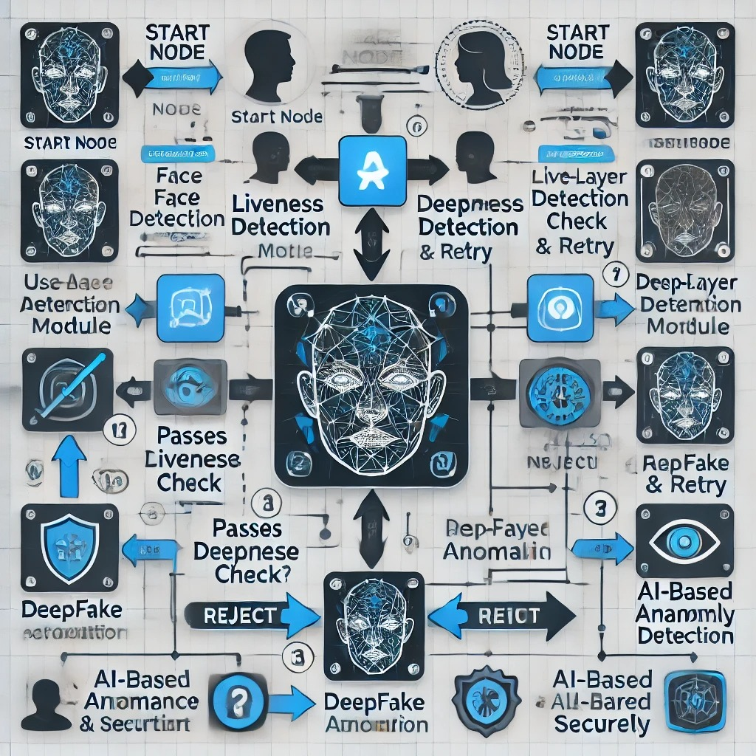

**Figure 1: Flowchart**

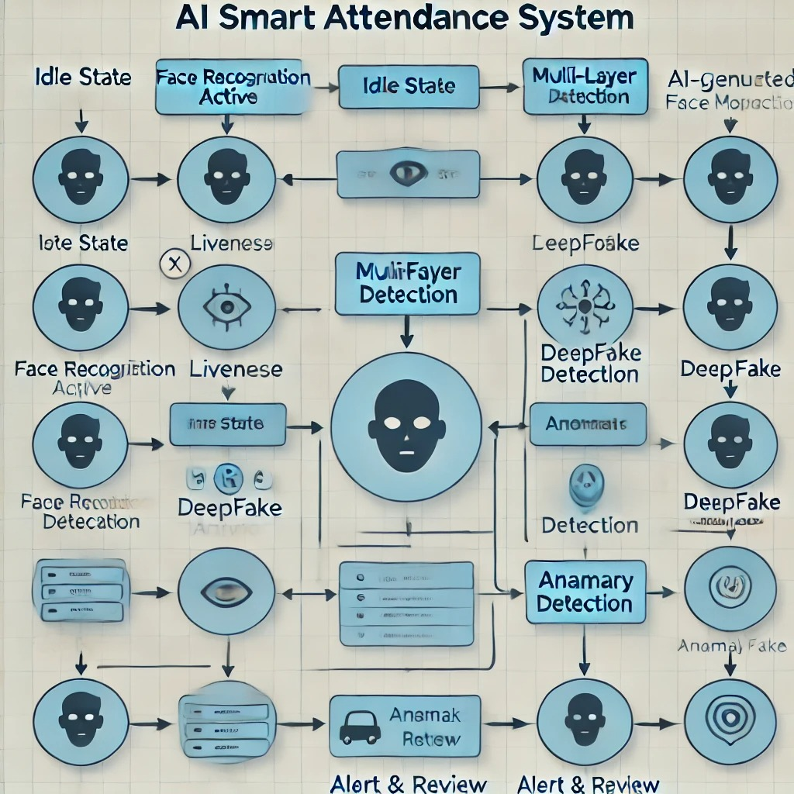

**Figure 2: State chart**

**H. EXISTING DATA:**

(NA)

**4. USE AND DISCLOSURE (IMPORTANT):** Please answer the following questions:

|  |  |  |
| --- | --- | --- |
| 1. Have you described or shown your invention/ design to anyone or in any conference? | YES ( ) | NO ( ) |
| 1. Have you made any attempts to commercialize your invention (for example, have you approached any companies about purchasing or manufacturing your invention)? | YES ( ) | NO ( ) |
| 1. Has your invention been described in any printed publication, or any other form of media, such as the Internet? | YES ( ) | NO ( ) |
| 1. Do you have any collaboration with any other institute or organization on the same? Provide name and other details. | YES ( ) | NO ( ) |
| 1. Name of Regulatory body or any other approvals if required.  * Ministry of Electronics and Information Technology (MeitY) – India * Bureau of Indian Standards (BIS) * General Data Protection Regulation (GDPR) – Europe * National Institute of Standards and Technology (NIST) – USA * ISO/IEC 27001 – Information Security Management System | YES ( ) | NO ( ) |

5. Provide links and dates for such actions if the information has been made public (Google, research papers, YouTube videos, etc.) before sharing with us.

(NA)

6. Provide the terms and conditions of the MOU also if the work is done in collaboration within or outside university (Any Industry, other Universities, or any other entity).

(NA)

**7. POTENTIAL CHANCES OF COMMERCIALIZATION**:

1. Educational Institutions & Universities – Schools and universities can integrate this system for secure student attendance tracking and exam monitoring, preventing proxy attendance in both online and offline classes.
2. Corporate Workplaces & IT Companies – Businesses can use this system for automated employee attendance, ensuring physical presence verification in remote and hybrid work models while preventing buddy punching fraud.
3. Government Organizations & Public Sector – Can be deployed in government offices, defence sectors, and law enforcement for secure access control and employee tracking, reducing identity fraud risks.
4. Healthcare & Hospitals – Useful for medical staff attendance tracking and secure patient identity verification, ensuring only authorized personnel access sensitive medical data.
5. Banking & Financial Institutions – Banks can integrate this system for staff authentication and fraud detection, improving security in high-risk financial operations and ATM monitoring.
6. Smart Cities & Public Transportation – Can be implemented in airports, metro stations, and bus terminals for ticket validation, security screening, and restricted area access control using AI-driven biometric verification.
7. Co-Working Spaces & Smart Offices – Startups, co-working hubs, and smart office buildings can integrate this technology for secure entry, visitor management, and automated employee check-ins with multi-layer fraud prevention.

**8. LIST OF COMPANIES:**

1. Microsoft (Azure AI & Face API) – Provides AI-driven biometric authentication and security solutions.

Website: <https://azure.microsoft.com/>

1. Amazon (AWS Rekognition) – Offers AI-powered face recognition and identity verification services.

Website: <https://aws.amazon.com/rekognition/>

1. Google (Google Cloud Vision & AI Security) – Specializes in cloud-based facial recognition and AI security.

Website: <https://cloud.google.com/vision>

1. IBM (IBM Watson AI Security) – Provides AI-driven identity verification, anomaly detection, and fraud prevention.

Website: <https://www.ibm.com/security>

1. NEC Corporation – A leader in biometric authentication and facial recognition for enterprise security.

Website: <https://www.nec.com/>

1. Thales Group – Develops secure identity and access control solutions using AI-powered biometric systems.

Website: <https://www.thalesgroup.com/>

9. Any basic patent which has been used, and we need to pay royalty to them.

(NA)

10**. FILING OPTIONS:** Please indicate the level of your work which can be considered for provisional/ complete/ PCT filings.

(COMPLETE)

11. **KEYWORDS:**

1. AI-powered attendance
2. Biometric authentication
3. Deepfake detection
4. Anomaly tracking
5. Facial recognition
6. Blockchain security
7. Behavioral biometrics
8. Privacy-preserving AI
9. Zero-trust authentication
10. IoT attendance systems
11. Federated learning security
12. AI fraud detection
13. Enterprise security
14. Cloud-based biometric system
15. AI-powered access control
16. GDPR-compliant attendance
17. Smart proctoring systems
18. Machine learning-based fraud prevention
19. Edge AI attendance tracking
20. Multi-modal biometric authentication

**NO OBJECTION CERTIFICATE**

This is to certify that Lovely Professional University, or its associates shall have no objection if Lovely Professional University files an IPR (Patent/Copyright/Design/any other) entitled “ AI-Based Smart Attendance System with Multi-Layer Anti-Spoofing and Anomaly Detection " including the names of, as inventors who is are students/employees studying/ working in our University/ organization. Further, Lovely Professional University shall not provide any financial assistance in respect of said IPR nor shall raise any objection later with respect to filing or commercialization of the said IPR or otherwise claim any right to the patent/invention at any stage.

*1) Goutam Pareek*

*2) Arjun Singh Shekhawat*

*3) Sanidhya Pant*